MAKING A CONNECTION
EXPERIENCE WEEK 2023

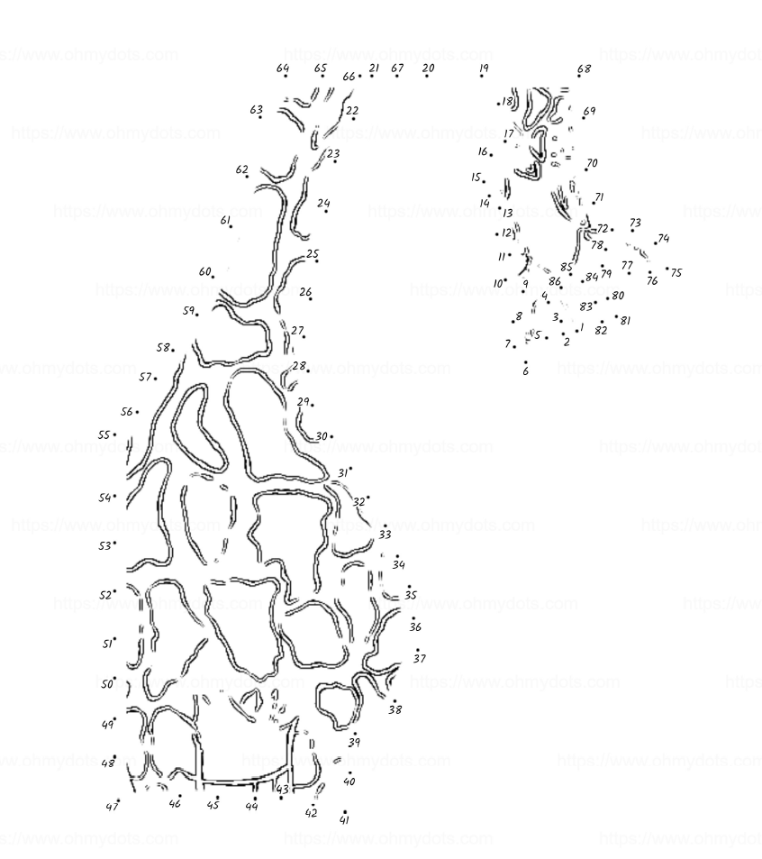

COMPLETE THE DOT-TO-DOT PUZZLE, COLOR IT AND SEND COMPLETED PICTURE TO patientexperience@cookchildrens.org TO BE ENTERED IN A RANDOM DRAWING FOR A GIFT CARD!

