Employee Portal Overview 
Overview: This guide provides Cook Children’s employees an overview of the Enterprise Health Employee portal.

To access the portal you will be given a link and will be able to sign in with your network ID and password.
2
3
1
1
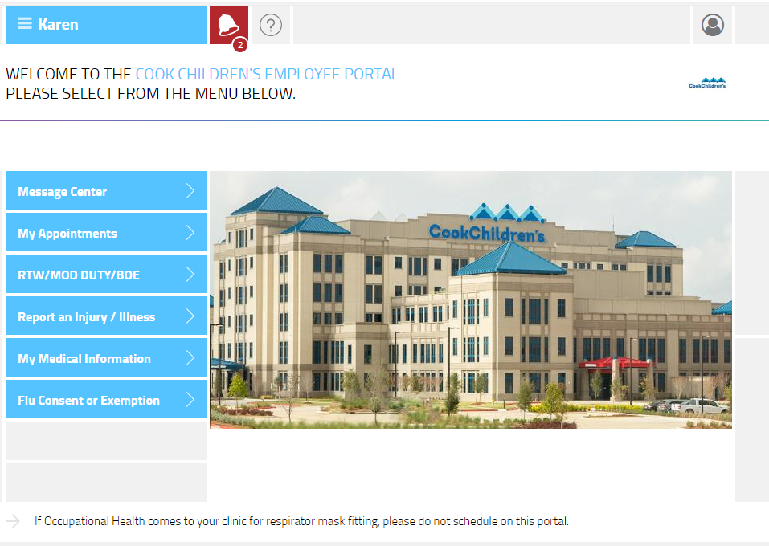
9
8
7
6
5
4
- Menu-access the dropdown menu to log out of the system
- Notification Bell-Access messages and portal notifications.
- Question Icon- View a list of available functions.
- Message Center- view and send messages to Occupational Health.
- My Appointments- View and make mask fit appointments
- RTW/MOD DUTY/BOE- Fill out Return to work form, upload and sign documents.
- Report and Injury/Illness-Report a work-related injury/illness/exposure
- My Medical Information- View and print your records
- Flu Consent or Exemption- Complete Flu Consent or apply for an exemption.

