
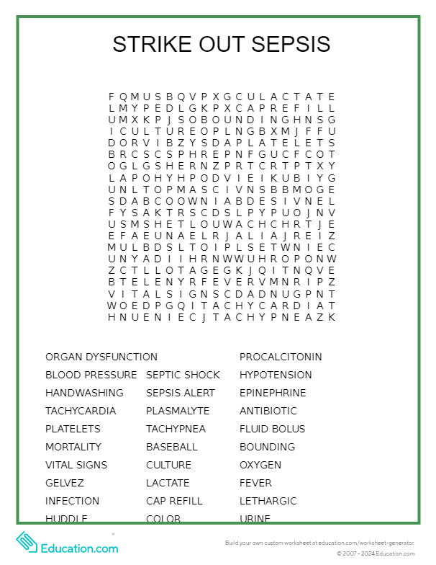

Name: Department: _______________
Let’s Go,
Cook,
Let’s Go!!

